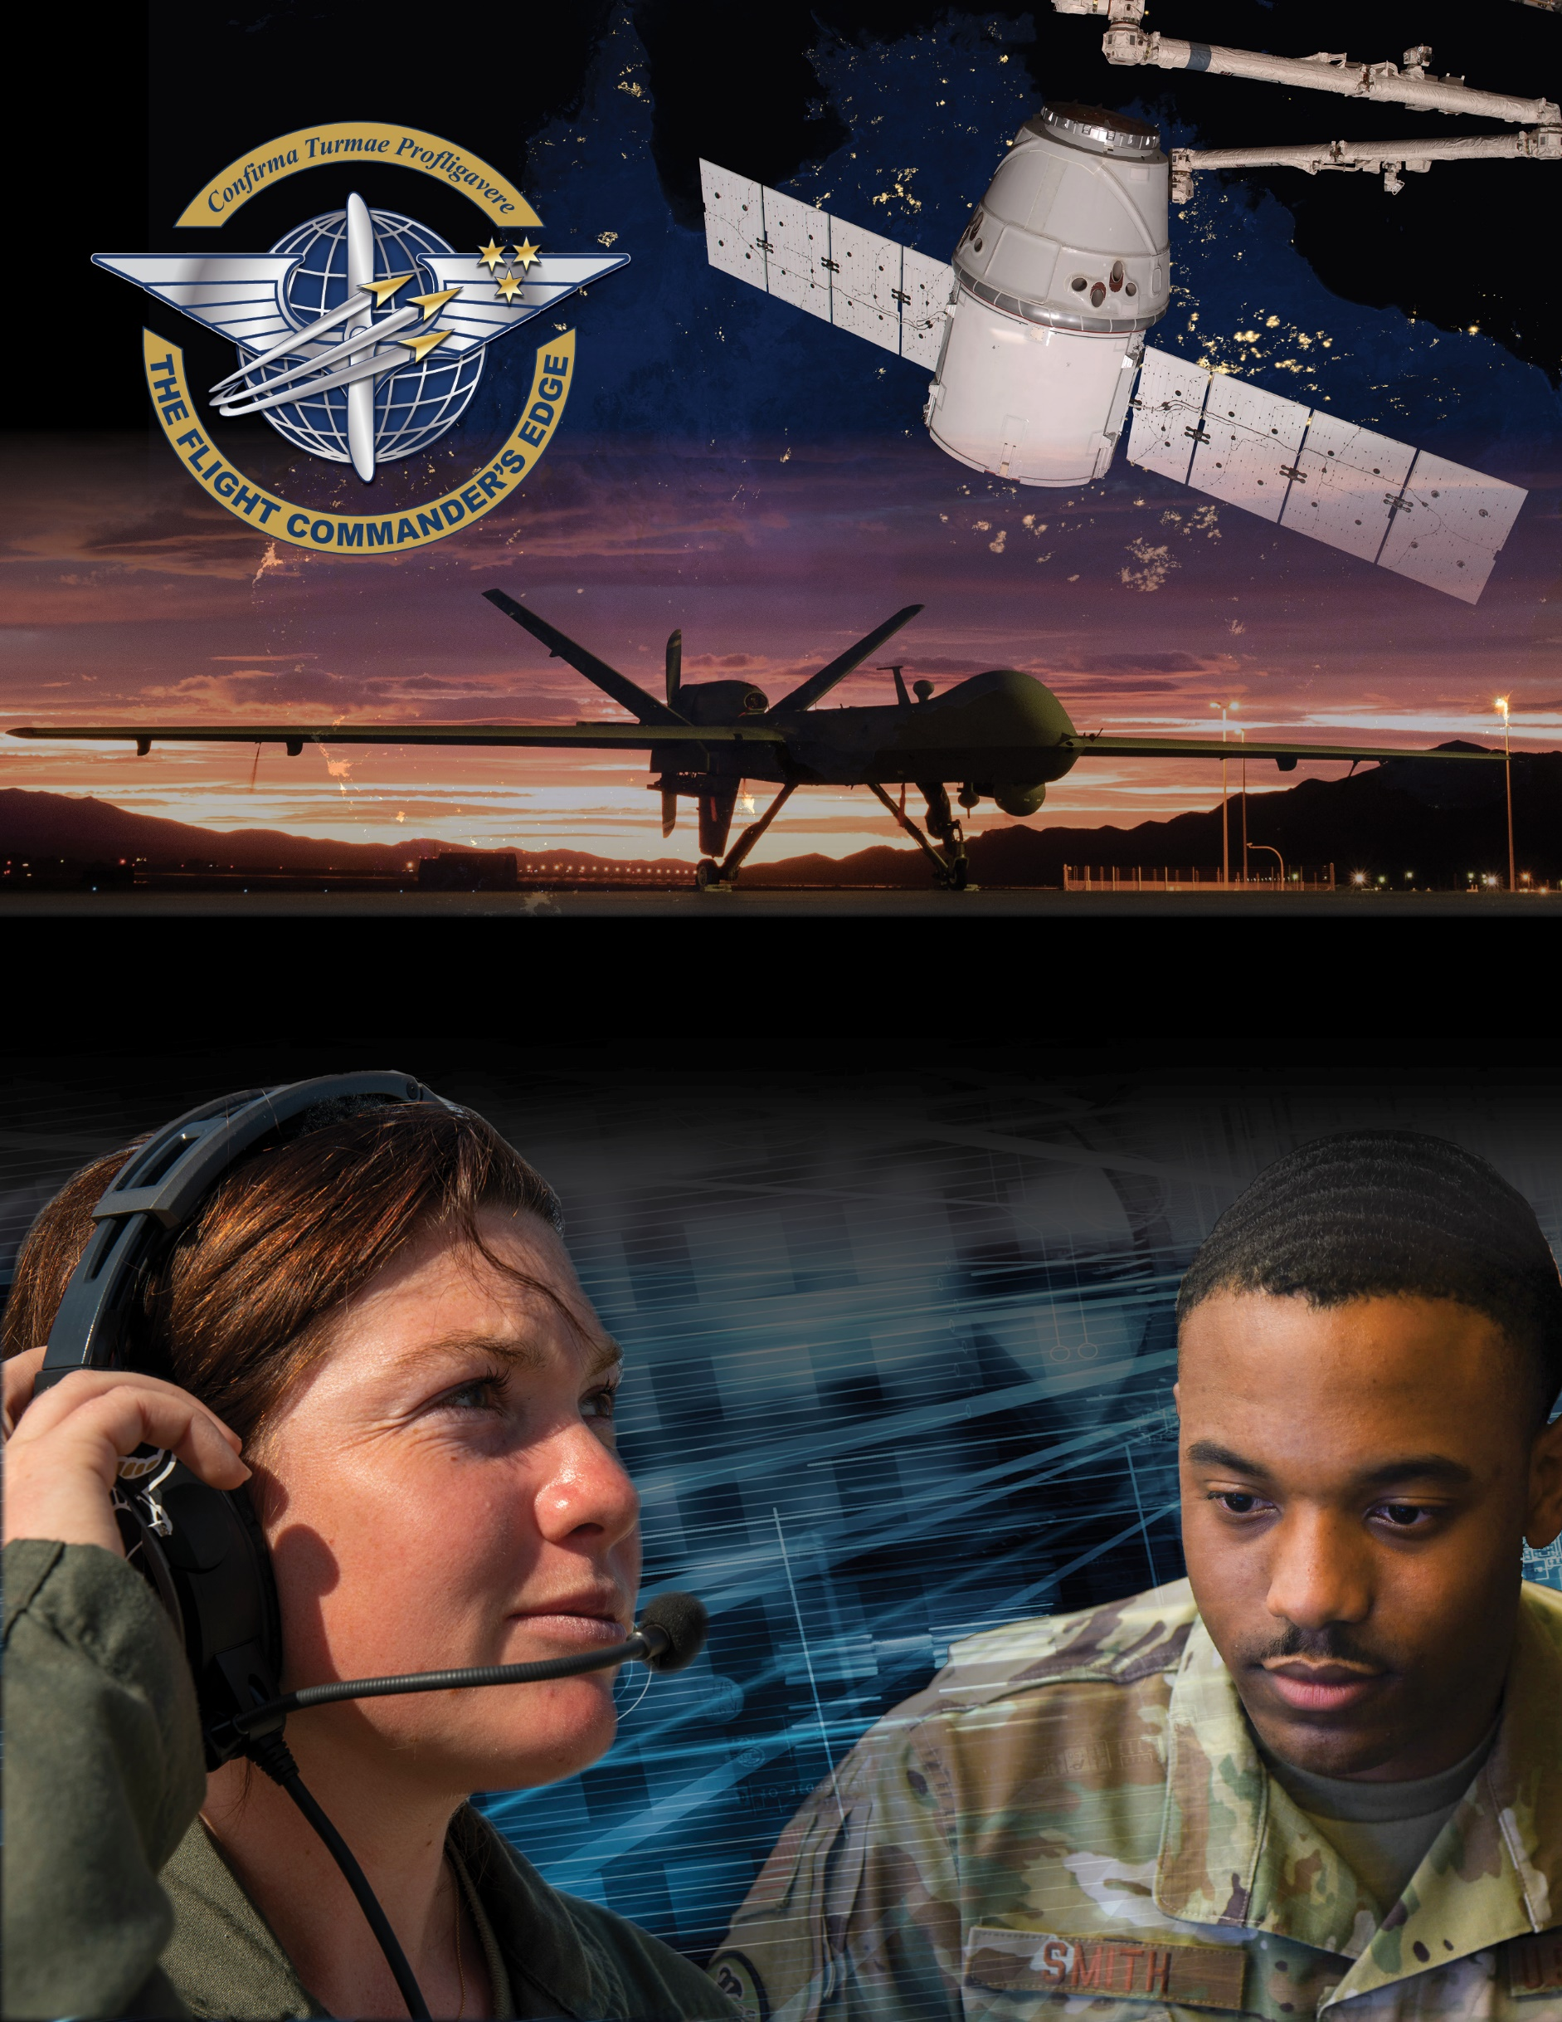

**Lesson Guide**

**Deployment**

***14 April 2025***

**Deployment**

### Purpose

This lesson guide is designed to support the local development of Flight Commander Leadership Course materials. Selected facilitators should use this guide as they prepare presentation materials. For more information on how lessons are structured, or how to use them in the course, see the ***Course Director’s Handbook*** or online Facilitator Resources.

### Scope

In November 2019, the SECAF and CSAF directed the Department of the Air Force to transform its Force Presentation methodology. Drawing from the National Defense Strategy, the service began an effort focused on presenting forces aligned to support long-term strategic competition and capable of being strategically predictable, but operationally unpredictable. This new framework is designed to meet Combatant Commanders’ requirements, provide Airmen and Guardian deployment predictability, and maintain home station readiness. Deployments can be at the unit level or for individuals. Members will have an AEF Indicator in the personnel system; commanders (or equivalent) are responsible for determining these codes for all assigned personnel.

Flight Commanders are responsible for tracking the readiness posture of their personnel. This requires you to broadly understand how force sourcing and individual deployments work. It is equally important for Flight Commanders to be involved in the training, health, and wellness of their flight members. They are charged with ensuring their personnel are ready to support deployment taskings, maintain overall readiness posture, and are fully supported during the deployment.

### Recommended Objectives

By the end of this lesson, the student should be able to:

1. Understand the deployment process and related resources.
2. Comprehend deployment types, preparation, execution, and associated challenges.
3. Recognize the support requirements necessary for deployed team members.

### Recommended POC / Presenter

1. Installation Deployment Officer/Unit Deployment Manager

* Squadron-level leader (DO, CC or equivalent)

### Recommended Length:

* 25 minutes (inclusive of questions)

### Recommended Approach

* Present informational slides with Q & A

### Lesson Connections

1. **Manning**-the mission must continue even when personnel are deployed. It is vital that no single point of failure exist on the personnel side to ensure that mission requirements can be met.
2. **Mission Command**-personnel must remain operationally flexible and take the initiative to meet mission requirements when other members of the unit are deployed.
3. **Taking Care of Families**-the stressors of deployment can bring extra challenges to both the military member and the family members left behind. Be sure to connect your audience to the Military One Source site (www.military onsesource.mil) for online deployment resources for the member as well as their family.